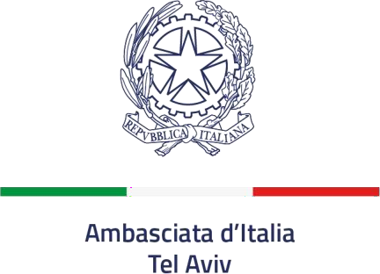

NOTICE

CALL FOR PROPOSALS BY SERVICE COMPANIES FOR THE ADJUDICATION OF CLEANING SERVICES FOR THE EMBASSY OF ITALY

The Embassy of Italy in Tel Aviv issued a call for proposals by cleaning companies to provide cleaning services at this Embassy of Italy (Trade Tower – 25 Hamered St. – 6812508 Tel Aviv). The Embassy has a surface of approximately 1.749 square meters (distributed on the 8th and on the 21st floors).

Date and Time
Weekdays (Monday to Friday). From 7.30 am to 13.30 (6 hours).

Specification of work force
One professional worker. Hourly wage: at least the minimum wage, according to the Minimum Wage Act.

Duration
The contract will start on January 1st 2026, and will end on December 31st 2026.

Recipients
This call for proposals is aimed to cleaning companies that meet the requirements described above, and that have the technical expertise and the financial and human resources to enter such agreement.

Duties and Activities

Daily cleaning
Floor sweeping and washing; dusting of office furniture; replacement of paper and soap in dispensers; garbage collection and disposal; cleaning glass doors; complete cleaning of kitchenettes, including appliances; cleaning tables; dish washing. Weekly cleaning
Floor vacuum cleaning; computers and electric devices (phones, switches, photocopiers, fax machines); cleaning shelves above a person’s heights; dusting of frames and paintings.

Monthly cleaning
Doors and door ports; dusting of lighting fixtures, panels, chair legs; cleaning cobwebs; refrigerator thorough cleaning.

Periodic cleaning (once every 4 months)
Window cleaning on their internal side only.

Cleaning materials and equipment

According to the Agreement all professional cleaning materials, equipment and tools shall be provided by the Contractor:

Cleaning materials (with good-quality standard):
Small bags (50/70) and large bags (75/90) Floor mats
Grease remover and limestone remover
Floor detergent and parquet detergent (no use of acids)
Dishwashing soap for the kitchenettes
Furniture spray and stainless steel spray Window/glass spray
Cleansers, floor detergents and bleach for the restrooms
Hand soap for the restrooms
Paper towels for the restrooms Toilet paper for the restrooms

Work equipment and tools (made by well-known manufacturers):
Vacuum cleaner / hoover Work overalls
Floor and microfiber mops Wipers
Brooms Buckets Shovels Gloves

Purpose
This call for proposals is aimed to start a constructive dialogue with all interested cleaning companies. At this stage, statements of interest submitted with the requested data will not be considered as binding for the Embassy. Cleaning companies that submit statements of interests will not gain preferred placement position in the decision making process.

Requirements
As a proof of sound business practices, applicants shall provide with the statement of interest the application form (“A-form”) and the following information:
- business license;
- company profile;
- letters of references (if available).

How to Submit a Statement of Interest
The statement of interest (with the attached “A-form”) must be sent by email no later than 2pm on November 30th 2025 to the address amm.telaviv@esteri.it (subject: “CALL FOR PROPOSALS FOR CLEANING SERVICES”).

Tel Aviv, October 30th, 2025

