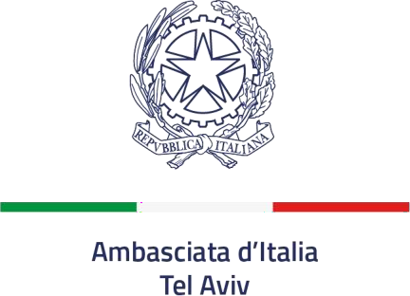

NOTICE

CALL FOR PROPOSALS FOR THE ADJUDICATION OF PEST CONTROL SERVICES AT THE RESIDENCE OF THE AMBASSADOR OF ITALY

The Embassy of Italy in Tel Aviv issues a call for proposals to provide pest control services at the Residence of this Embassy (Alonim St. n. 6, Ramat Gan, Tel Aviv).
The Residence has a surface of approximately 3.900 square meters.

Date and Time
At least 2 times every month and when necessary.

Duration
The contract will start on January 1st 2026 and end on December 31st 2026.

Recipients
This call for proposals is intended to pest control companies that meet the requirements described above, and that have the technical expertise and the financial and human resources to enter such agreement.

Activities
- Pest control against parasites, rodents, mosquitos, roaches, ants, and any other insects;
- Inspecting mosquitos breeding areas to kill larvae and aerosol spraying by ground equipment to kill adult and larval mosquitoes;
- Positioning bait traps against rodents and roaches (if necessary).

Equipment
All chemicals/materials (i.e. pesticides, insecticides, rodent traps, poisoned baits, etc.), uniforms and tools shall be provided by the Contractor. All chemicals must be approved and authorized under the Israeli legislation.

Work attire (uniforms) will be provided by the Contractor to full-time employees. The Contractor must be in possession of an appropriate business license. It must be qualified, licensed and registered to do such business (pest control) in the State of Israel.

Purpose
This call for proposals is aimed to starting a constructive dialogue with all interested companies. At this stage, statements of interest shall not be considered as binding. Those submitting statements of interests will not gain preferred placement position in the selection procedure.

Requirements
As a proof of sound business practices, applicants shall provide with the statement of interest the application form (“A-form”) and the following information:
- business license;
- company profile;
- letters of references (if available).

How to Submit a Statement of Interest
The statement of interest (with the attached “A-form”) must be sent by email no later than 2pm on November 30th, 2025 to the address amm.telaviv@esteri.it (subject: “CALL FOR PROPOSALS FOR PEST CONTROL SERVICES”).

Tel Aviv, October 30th 2025

